[Array 15 (2022) 100236](https://doi.org/10.1016/j.array.2022.100236)

|  |  |  |
| --- | --- | --- |
|  |  |  |
|  | Contents lists available at ScienceDirect |  |
| Array |
| journal homepage: [www.sciencedirect.com/journal/array](https://www.sciencedirect.com/journal/array) |

Mechanisms and techniques to enhance the security of big data analytic framework with MongoDB and Linux Containers

Akalanka Mailewaa,*, Susan Mengelb, Lisa Gittnerc, Hafiz Khanc

a *St. Cloud State University, Department of Computer Science and Information Technology, St. Cloud, Minnesota, USA* b *Texas Tech University, Department of Computer Science, Lubbock, TX, USA*   
c *Texas Tech University, Department of Public Health, Lubbock, TX, USA*

|  |  |
| --- | --- |
| A R T I C L E I N F O | A B S T R A C T |
| *Keywords:*  Vulnerabilities  Threats  Big-data  MongoDB  Data security  Docker & Singularity  Linux Containers  Sensitive data  HIPAA  Privacy | The frequency and scale of unauthorized access cases and misuses of data access privileges are a growing concern of many organizations. The protection of confidential data, such as social security numbers, financial informa-tion, etc., of the customers and/or employees is among the key responsibilities of any organization, and damage to such sensitive data can easily pose a threat to the future of a business and the security of the customers. Therefore, this paper proposes and implements some security mechanisms and techniques, such as secure authentication, secure authorization, and encryption, to assure the overall security of a big data analytic framework with MongoDB free community edition. This paper presents the fourth phase of our continuous research where in the first phase we proposed a data analytic framework with MongoDB and Linux Containers (LXCs) with basic security requirements. Next, in the second phase we proposed a vulnerability analysis testbed to find vulnerabilities associated with the system. Finally, in the third phase we discussed in detail root causes and some prevention techniques of vulnerabilities found in the system. In addition, this paper introduces a new security mechanism for privacy preserving data handling with MongoDB to ensure the privacy of the data before being processed. Our results show, with our initial model of the analytic framework, how well our newly introduced security mechanisms work and how these security mechanisms and techniques can be used to assure the confidentiality, integrity, and availability (CIA) of any data science project conducted on our proposed an-alytic framework. In addition, these security mechanisms and techniques help us to strengthen the current system against zero-day attacks where attacks on vulnerabilities that have not been patched or made public yet. Therefore, our vulnerability analysis testbed which is proposed in the second phase of this research will not be able to finds vulnerabilities related to zero-day attacks. |

**1. Introduction**

Modern data analytic frameworks often operate in highly dynamic and uncertain environments. Therefore, providing security for such frameworks is a huge challenge since in a networked environment, the risks to valuable and sensitive data are greater than ever before [1]. Understanding and leveraging the inter play of these security areas di-mensions can help design more secure systems with more effective policies. This paper focuses on how to improve the security of the evolutionary development of a high-performance big data analytic framework by introducing some security mechanisms and techniques. The ultimate goal is to systematically design a secure data analytic framework that is capable of providing guaranteed security to its users

* Corresponding author.

*E-mail address:* [amailewa@stcloudstate.edu](mailto:amailewa@stcloudstate.edu) (A. Mailewa).

such that it fulfills regulatory compliance mandates, such as Health In-surance Portability and Accountability Act of 1996 (HIPAA), if research focuses on healthcare data.

One of the specific cases that influenced this study is the data security requirements of the Texas Tech University (TTU) EXPOSOME big data project, funded by NIH and NSF. This project is designed to pinpoint the exposures and their impact on the health of affected people within their lifespan. However, data analysts have been struggling to gain insight from raw data because of the differences in data formats. Furthermore, data must be secured and privacy-assured despite the continuous addi-tion of more data including those that are de-identified but still pro-tected personal health records [2]. Currently, a transdisciplinary team is in the process of implementing a secure system to convert these data and

<https://doi.org/10.1016/j.array.2022.100236>   
[Received 20 December 2021; Received in rev](https://doi.org/10.1016/j.array.2022.100236)ised form 17 July 2022; Accepted 18 July 2022   
Available online 4 August 2022   
[2590-0056](http://creativecommons.org/licenses/by-nc-nd/4.0/)/© 2022 The Author(s). Published by Elsevier Inc. This is an open access article under the CC BY-NC-ND license (<http://creativecommons.org/licenses/by-nc-nd/4.0/>).

*A. Mailewa et al.*  *Array 15 (2022) 100236*

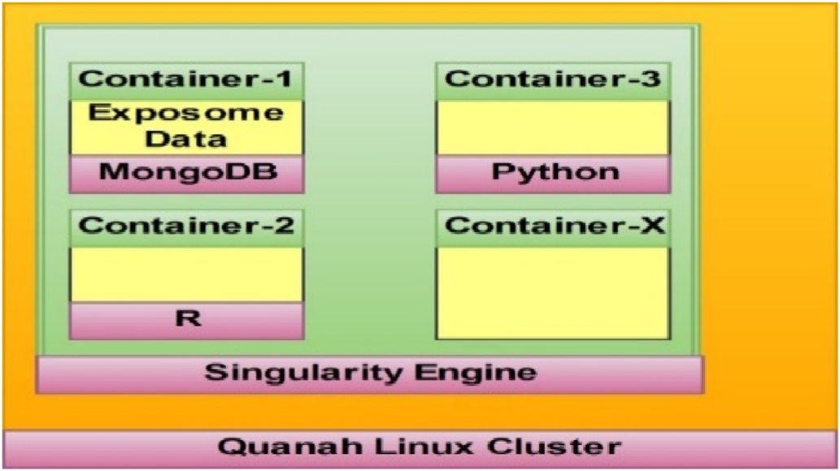

**Fig. 1.** Data analytic framework with MongoDB and Singularity.

store these various data formats in the MongoDB database for further analysis of the TTU EXPOSOME Project data. Four main areas are addressed in this project in order to protect the data and provide un-impaired access to the authenticated researchers. These four areas include database security (Server with LXCs), network security, web application security, and physical security. As mentioned earlier, the ultimate goal is to provide a secure analytic framework. This research, therefore, investigates ways in which protected data and access to the EXPOSOME data can be secured while avoiding performance degrada-tion during access [3] even when insecure tools may be used.

Akalanka et al. [4] proposed a conceptual secure data analytic framework with MongoDB and LXCs in the first phase of the research. This framework, illustrated in Fig. 1, shows how the current MongoDB database server is implemented with EXPOSOME data on a Singularity Linux container. In the meantime, the remaining containers facilitate other services to the entire data analytic framework, where the host operating system is a Linux node (Quanah Linux Cluster) attached to the TTU network. In the second phase of the research, Akalanka et al. [5] presented a dynamic and portable vulnerability assessment system testbed made with Singularity Linux containers (Fig. 2). Equipped with seven testing tools, the testbed is designed to find vulnerabilities in the data analytic framework proposed in phase 1. The tools facilitate vulnerability testing in the container network, inside the host machine, and outside the network. The implementation of the testbed can be done in three steps: first, the MongoDB server and clients are deployed. Then,

“OpenVAS,” “Dagda,” “PortSpider,” “MongoAudit,” “NMap,” “Meta-sploit Framework,” and “Nessus” vulnerability assessment tools as Docker images are added to the seven separate Singularity containers to complete the testbed with seven testing tools. Finally, in order to iden-tify the root causes of vulnerabilities and remove the available vulner-abilities found in phase two, “Vulnerability Prioritization, Root Cause Analysis, and Mitigation” are performed. In the third phase of the research Akalanka et al. [6] discussed multiple different ways to prior-itize vulnerabilities found in the second phase of the research, discov-ered root causes of those vulnerabilities, and proposed and implemented some mitigation techniques against those vulnerabilities found so far in the Secure Data Analytic Framework implemented with MongoDB on Singularity Linux Containers. In summary, the third phase of the research answered the question, “How do we mitigate vulnerabilities found in the current system by analyzing their root causes?” research question by involving three sub-steps: 1. Vulnerability prioritization, 2. Root causes analysis, and 3. Prevention techniques. This phase (fourth phase) of the research answers the research question, “RQ: How does the data analytic framework with MongoDB and LXCs is designed with enhanced security features?” by introducing some security mechanisms and techniques to the current system, such as authentication, authori-zation, privacy preserving data handling, and encryption.

Initially the paper discusses in brief the background with the related work. Next, it presents the methodology of security mechanism imple-mentations one by one for authentication, authorization, privacy pre-serving data handling, and encryption. Thereafter, paper presents results related to authentication, authorization, privacy preserving data handling, and encryption in detail. Finally, the paper concludes with the power of the current system and some future suggestions to improve the current system security, such as block-chain based security [7,8] and how human behaviors will affect the system security.

**2. Background and related work**

We In this section, we introduce a security model for the stored data in the MongoDB database server within Singularity Linux containers. During transmission, security mechanisms are used to authenticate, authorize, and encrypt data while data-at-rest is used to prevent vul-nerabilities. Furthermore, a mechanism is proposed and implemented for privacy preserving data extractions, transmissions, and loadings, by converting the actual data format to numerical data representation.

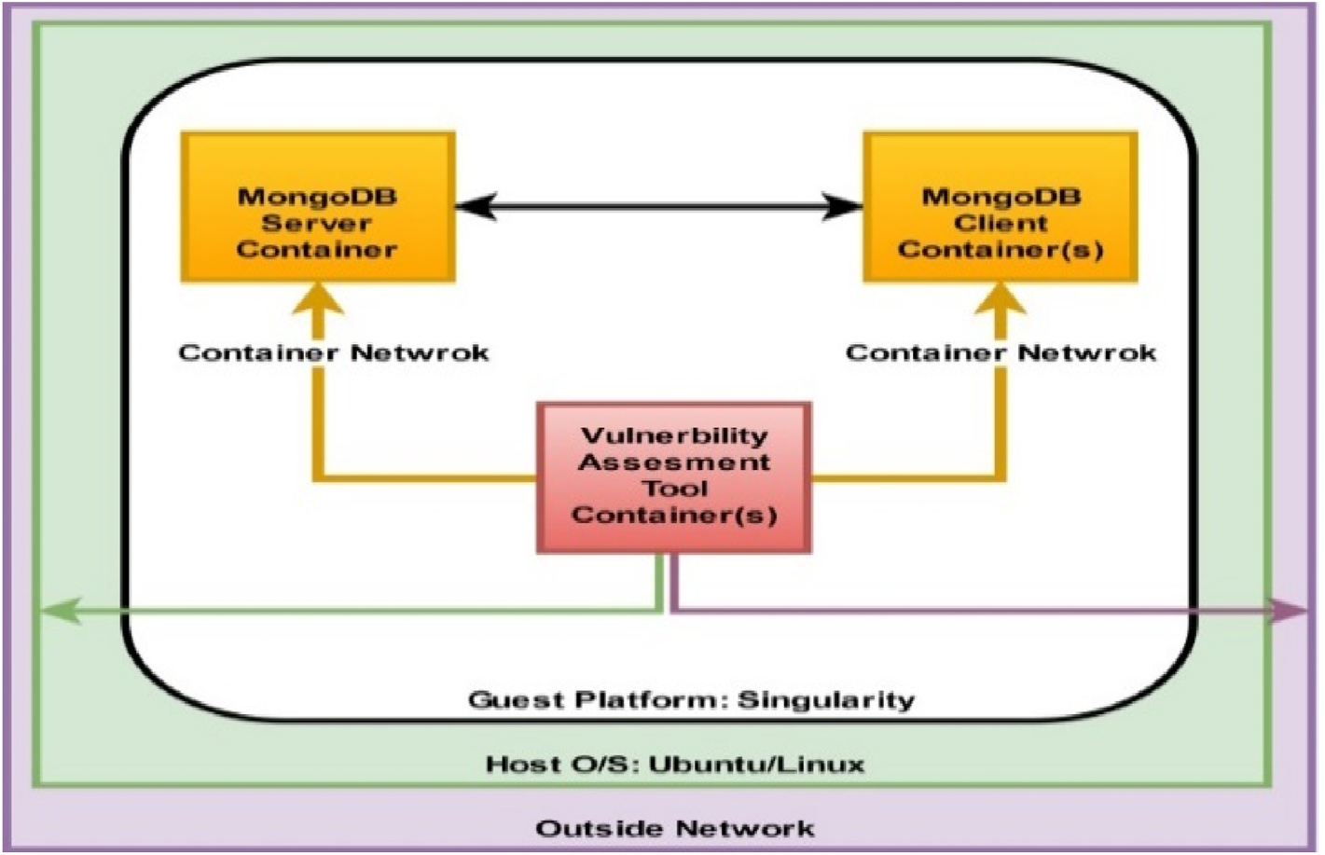

**Fig. 2.** LXCs based vulnerability assessment testbed.

2

*A. Mailewa et al.*  *Array 15 (2022) 100236*

Subsequently, we introduce several new techniques that we intend to implement to meet our future research goals as we create a more secure platform to deal with sensitive data and to comply with policies, such as HIPAA.

*2.1. Authentication*

Even though the MongoDB community edition supports multiple authentication mechanisms, such as SCRAM-SHA-1, MongoDB-CR, and x.509 Certificate authentication [9], this edition does not have an authentication mechanism by default. Therefore, we intend to use built-in technologies to implement a password-based authentication mechanism, until we propose a more secure, stronger mechanism using Mongoose [10–12] and bcrypt module with Node. js [13]. Mongoose is an elegant MongoDB object data modeling library for node. js, as well as an object data mapping solution that is capable of organizing and structuring data [14,15]. There is also the option to use the proxy authentication mechanisms, such as Kerberos and Lightweight Directory Access Protocol (LDAP) separately, which is a more complicated process [16–18]. Thus, we plan to encrypt passwords (or other data) through Mongoose before saving them in the MongoDB database server, and this method can also be used to encrypt data-at-rest.

*2.2. Authorization*

Since MongoDB does not enable access control by default, the authorization mechanism decides the database resources and operations accessible to the verified users [19,20]. After installation, nine control roles defined by the system are available with MongoDB. This research specifies the basic database policy, which guides the steps of access control implementation. The initial focus is on one regular user and the system administrator who has full permission. Complying with the principal of minimal authority in setting roles that determine the amount of access per user, the other users have lesser permission levels.

*2.3. Privacy preserving data extractions, transmissions, and loadings*

Our proposed privacy preserving data handling mechanism converts the data header and file name into a numerical data header and file name representation when loading data into MongoDB; thus, reducing the ability to determine what a particular column’s values and/or file name represent or mean. For every document or file loaded into Mon-goDB, MongoDB creates a key-value pair for each row inserted, usually of the format ‘Header: it’s Value’. These headers are usually of the type ‘String’ of varying lengths. In this phase, the ‘Header Formatter’ assigns for every unique header a new integer value and this integer value acts as the identifier for that header in the system. Conflict resolution be-comes essential at this stage since many cases occur in which the same header is used to identify different parameters. Keeping such headers as they are would only lead to ambiguity and confusion during data se-lection; multiple header use must be resolved. The system solves this multiple header use with header formatting. The header formatter as-signs a unique integer ID to every unique header. If the header is not unique, the description associated with the header is checked. If the description of the recently read header matches the description of any of the similar non-unique headers, the same value that is assigned for the other matching header is assigned to the recently read header. If the description of the recently read header is different from the descriptions of all the other matching headers, then the new header is a conflicting header and a new integer ID is assigned to it. The system also maintains a separate metadata collection for all conflicting headers. During the Header mapping stage, the data processing stage defines and populates a collection to keep track of the headers and the files in which they are present while the data loading process is building the data dictionary. This metadata is particularly important during the retrieval stage [2, 21–24].

3

*A. Mailewa et al.*  *Array 15 (2022) 100236*

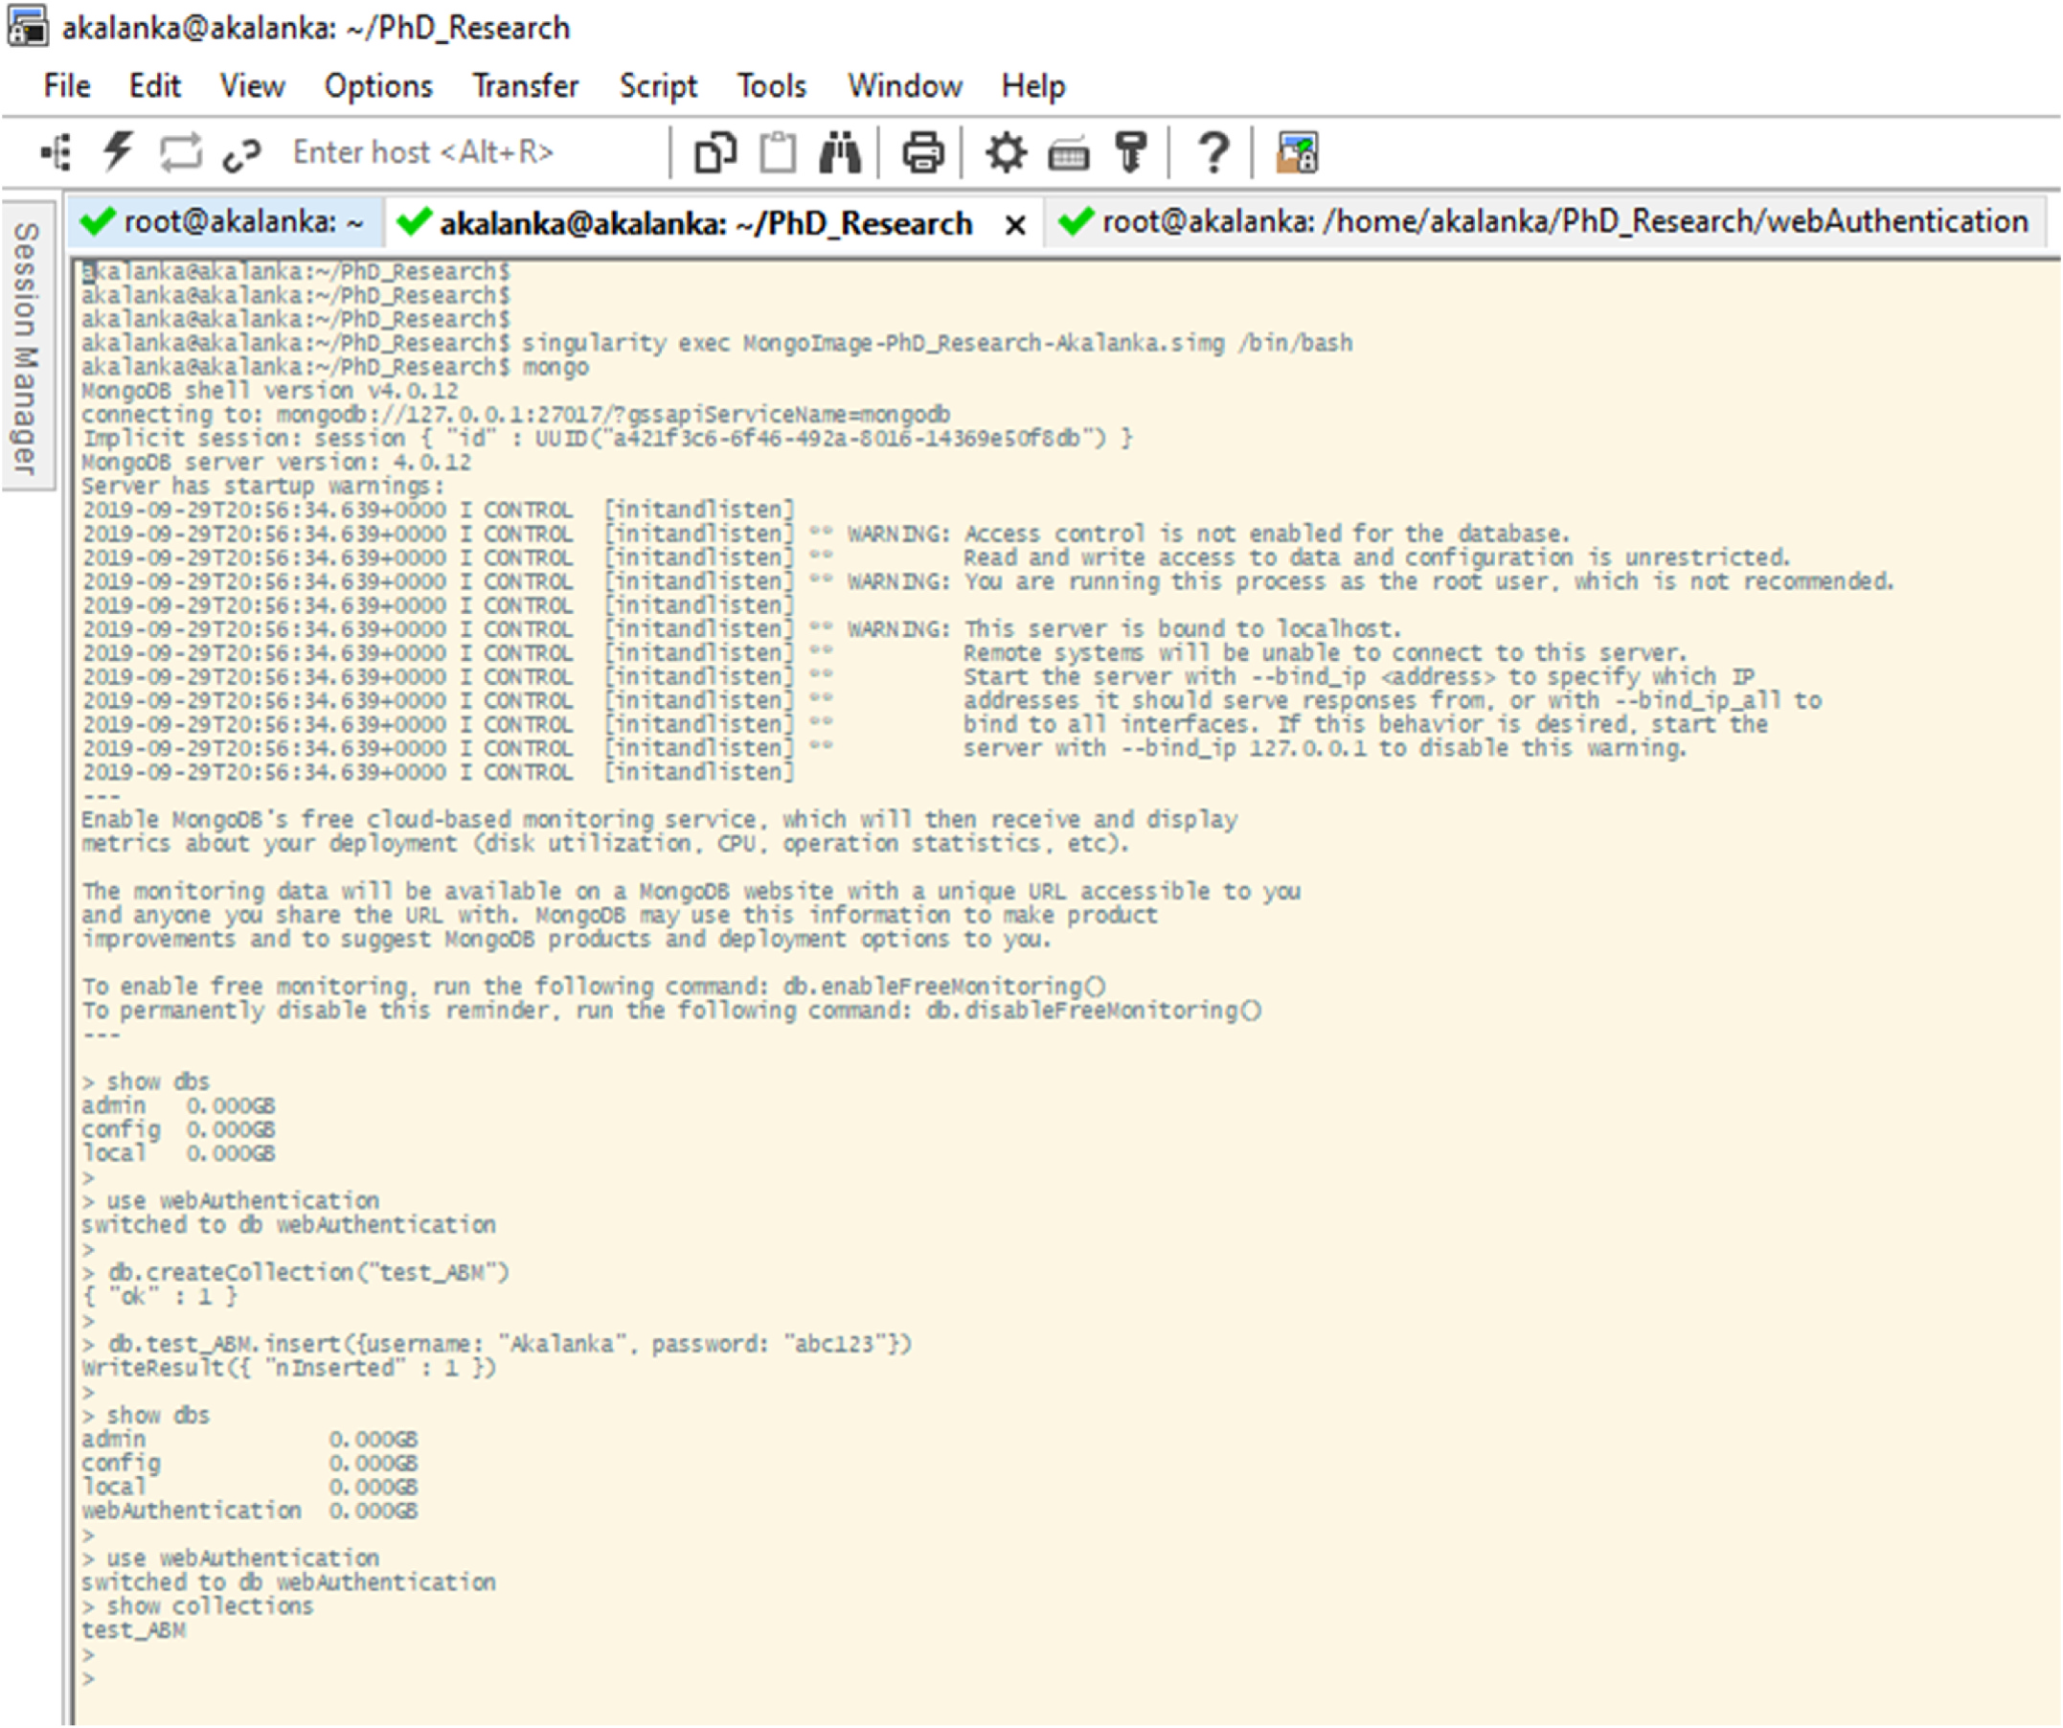

**Fig. 3.** MongoDB client is started and “webAuthentication” database is created.

process allows it to find the vulnerable source-level program statements of any given out-of-bound exploit. In every vulnerability test performed in the Wilander’s buffer overflow benchmark test-suite, AutoPag is able to successfully create its own fine-grained source code patch as a tem-porary solution within seconds of finding the root-cause. Moreover, the developers have built a proof-of-concept system in Linux with promising preliminary results, and the evaluations with real-world out-of-bound exploits have established AutoPag’s practicality and effectiveness.

According to Fernandez [39], patches are not the best solution to fix the security vulnerabilities in software. He points out how local fixes are not architectural solutions and how a patch that is not implemented in an architectural mode can create reconfigured or redundant patterns in the system. Thus, highlighting the possibility of patches opening doors for new attacks, Fernandez proposes two solutions to improve the se-curity of software design: the first is to examine the final production code and search for possible problems; the second is to plan for security from the beginning of the software development life cycle. Even though there are some issues in the approach, Fernandez supports the method of implementing security principles from the beginning of the life cycle to effectively attend to system security.

Youssef [40] proposes a secure healthcare information system that

4

*A. Mailewa et al.*  *Array 15 (2022) 100236*

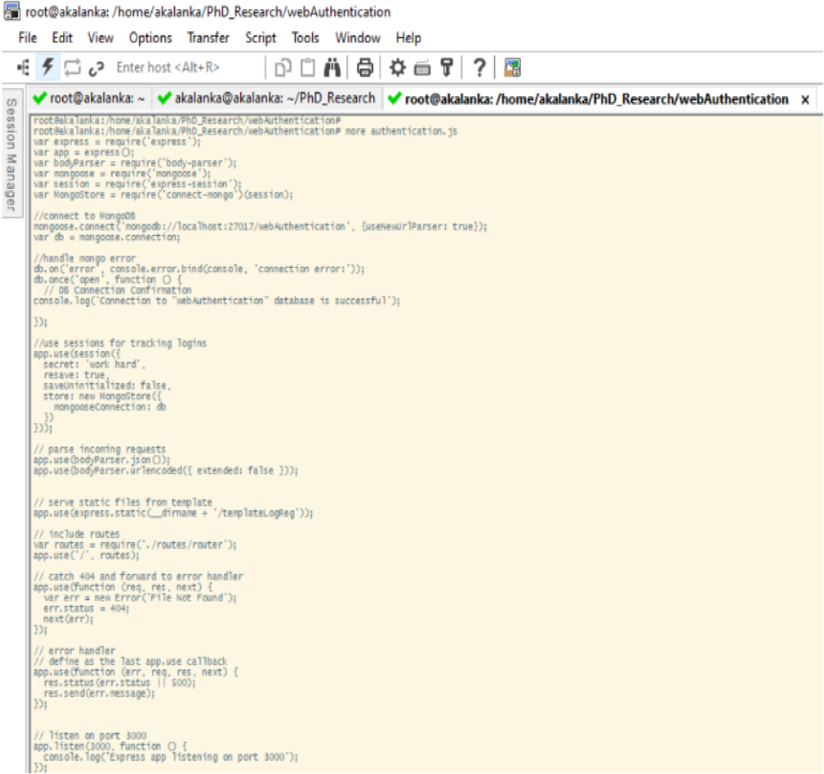

**Fig. 4.** “Authentication.js” Java-Script file to set up initial configurations.

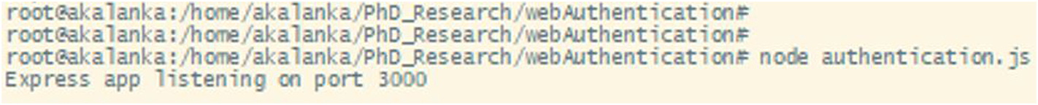

**Fig. 5.** Application is stared and listening on port 3000 for web connection.

complementary metrics to provide an accurate evaluation in the process of determining the level of security of a network that oversees the se-curity system status during current and potential future threats. The project considers security as a multidimensional aspect and uses a sto-chastic modeling technique with attack graphs. Meanwhile, the frame-work ensures a better understanding, along with a thorough system analysis through the use of Absorbing Markov Chains and the Common Vulnerability Scoring System (CVSS) framework.

Previous work focuses on specific aspects of security and privacy

5

*A. Mailewa et al.*  *Array 15 (2022) 100236*

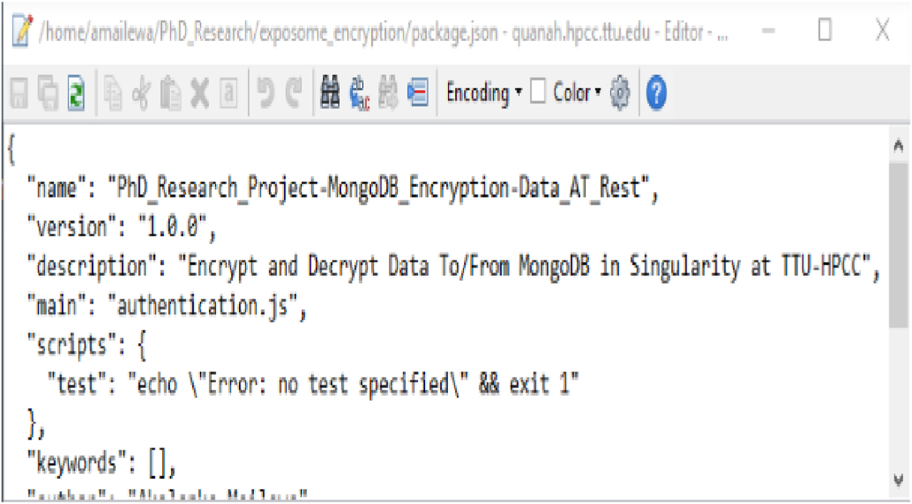

**Fig. 6.** Initial “package.json” file.

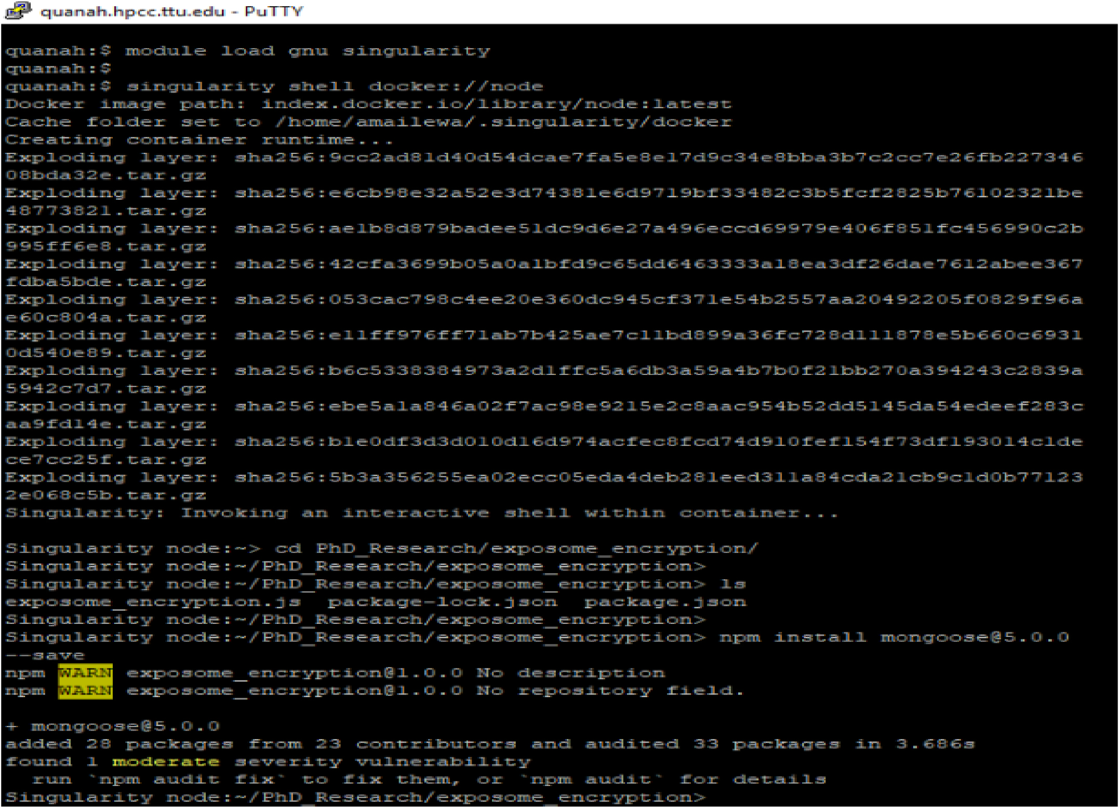

**Fig. 7.** Load Singularity and NODE package as an image and installation of Mongoose and other packages as a Node Module in Singularity.

**3. Methodology and experiments**

This section discusses and proposes the techniques that are appro-priate to remove vulnerabilities to improve the security of the data an-alytic framework with MongoDB in Singularity Linux containers mainly

6

*A. Mailewa et al.*  *Array 15 (2022) 100236*

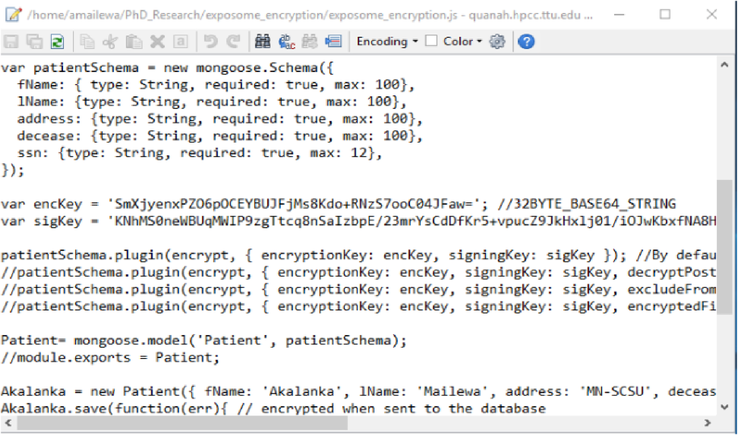

**Fig. 8.** “Exposome_encryption.js” Java-Script to create the data base model.

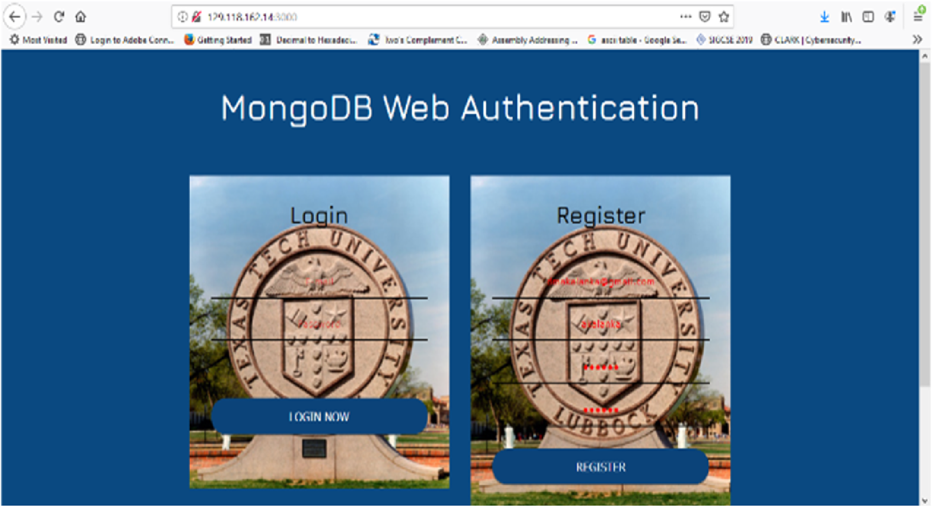

**Fig. 9.** User registration and login portal for MongoDB.

*3.1. Authentication*   
 To authenticate as a user, MongoDB server must be provided a

7

*A. Mailewa et al.*  *Array 15 (2022) 100236*

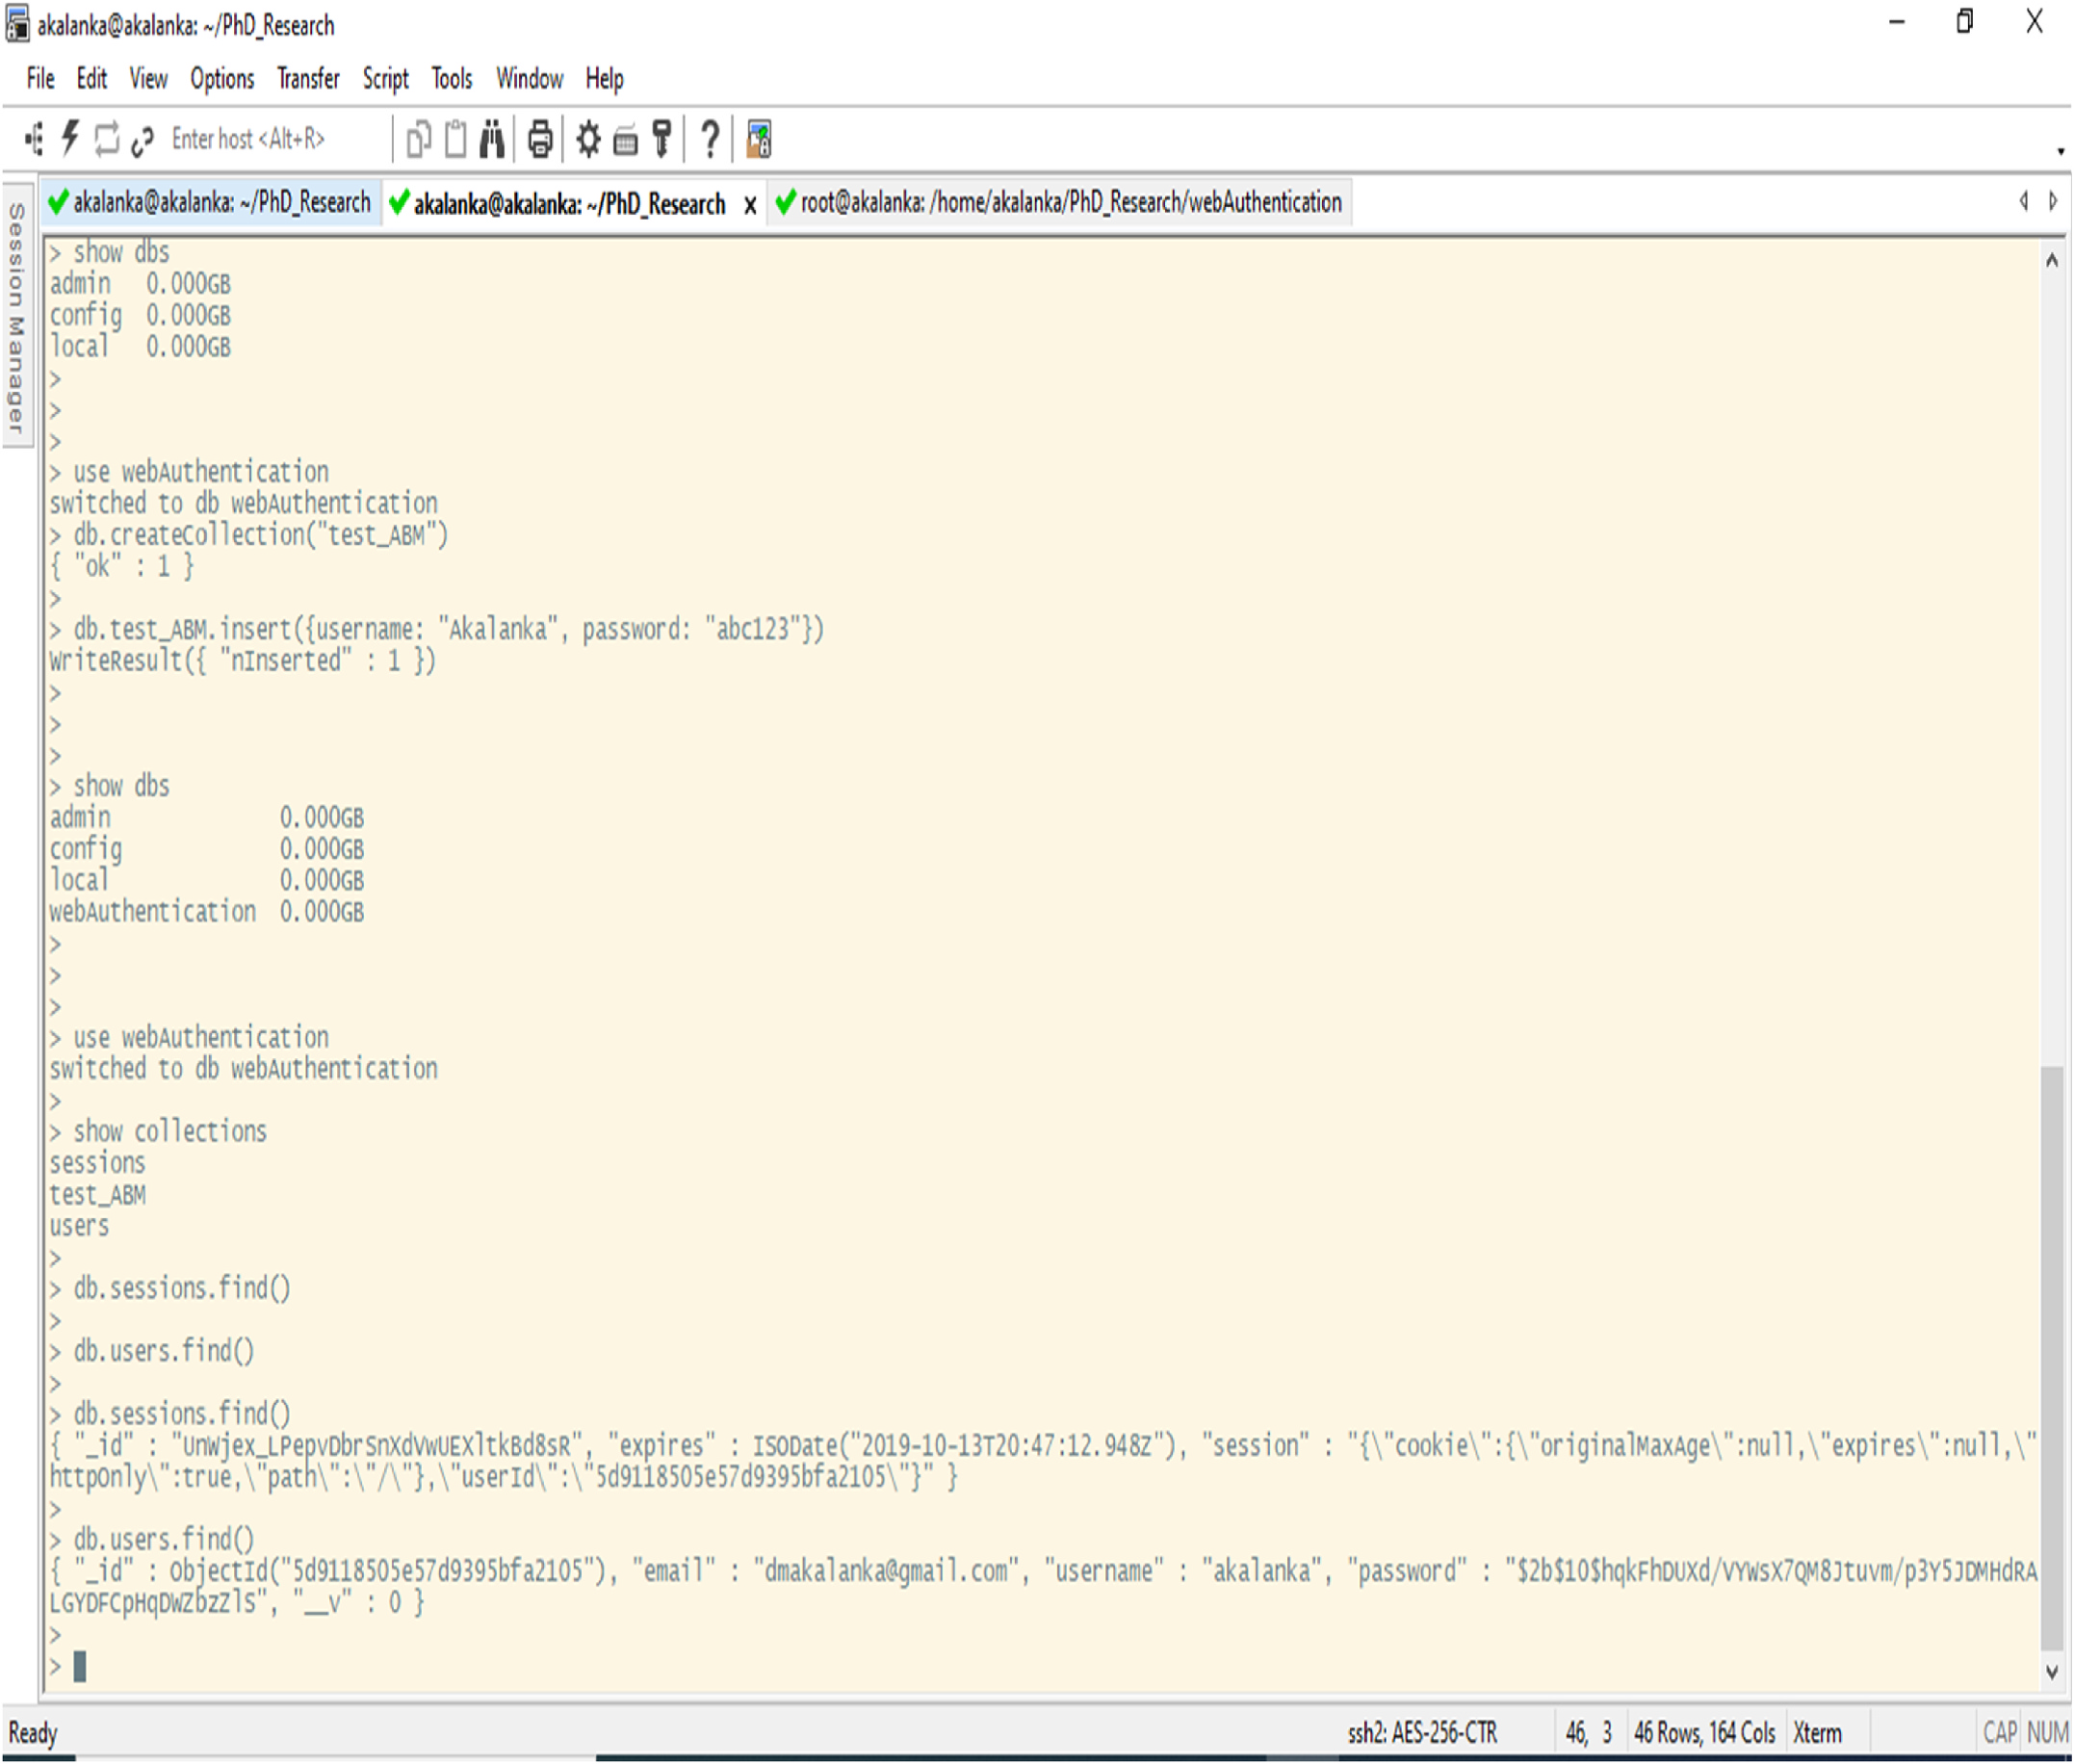

**Fig. 10.** After creating a user, user passwords are hashed and stored in the “users” collection of the “webAuthentication” database.

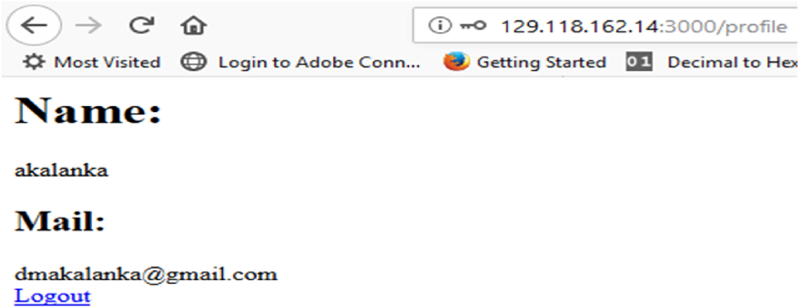

**Fig. 11.** Sample web page that indicate the successful login.

–authenticationDatabase) when connecting to the mongod or mongos instance, or connect first to the mongod or mongos instance, and then run the authenticate command or the db. auth() method against the authentication database [43,44]. As we discussed before, by default

8

*A. Mailewa et al.*  *Array 15 (2022) 100236*

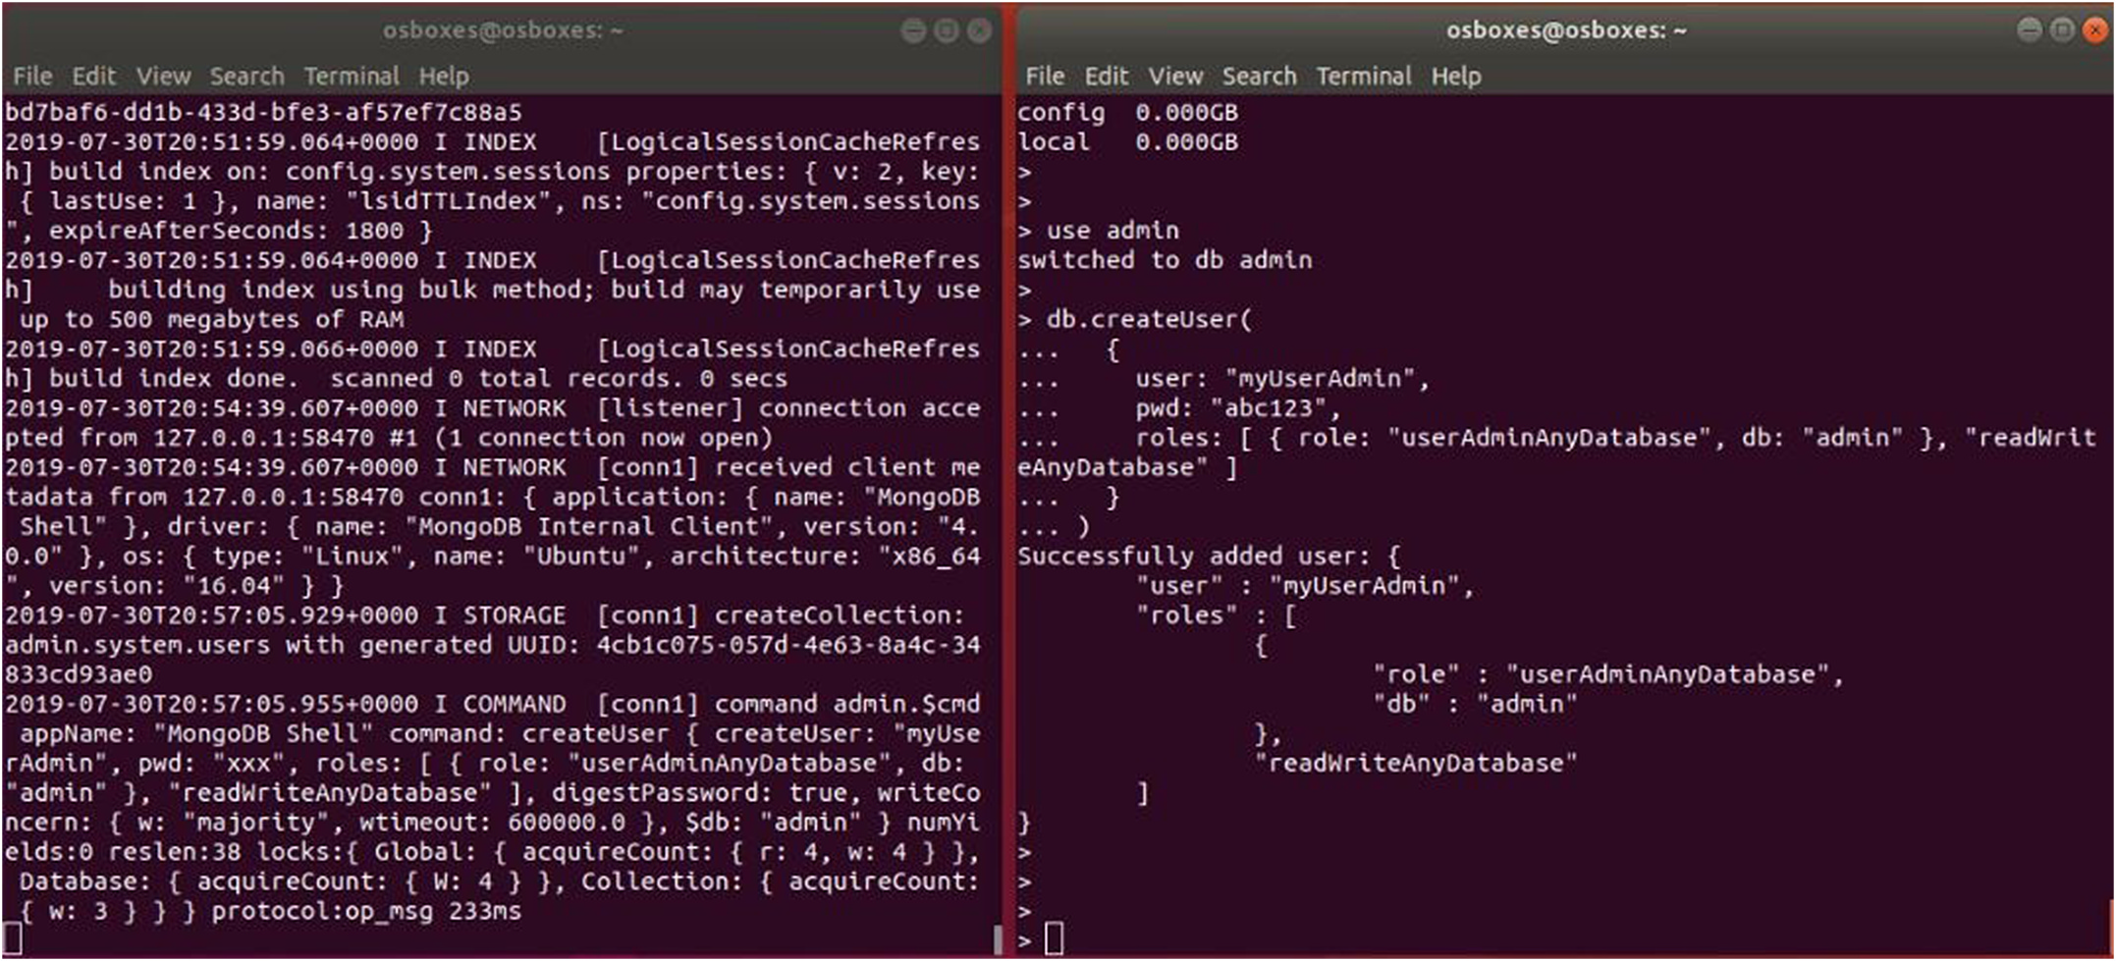

**Fig. 12.** While server is listing at left side, Client at right side adds the administrator.

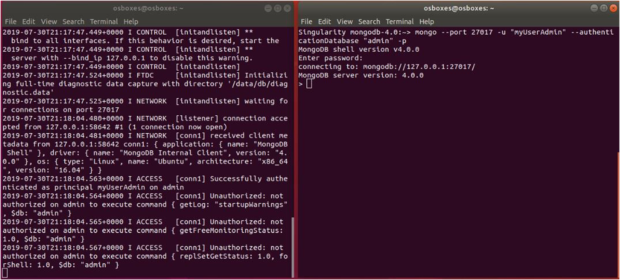

**Fig. 13.** While server is listing at left side, Client at right is authenticated as admin.

“Express.js”, and “bcrypt” to implement a web-based authentication process. Mongoose is an Object Data Modeling library for MongoDB and Express. js. It manages relationships between data, provides schema validation, and is used to translate between objects in code and the representation of those objects in MongoDB [45]. Express. js, which is another form of the JavaScript runtime based upon the Node. js plat-form. This enables us to execute javascript code when interacting with our MongoDB application [46]. Finally, bcrypt is used in order to protect the password information within our database, such that bcrypt is a password hashing function based on the Blowfish cipher [47]. This se-curity mechanism involves following three steps to gain access to a database.

**Step 1**: Deploy an instance of MongoDB server and client on two Singularity containers. Then, created the “webAutehntication”

9

*A. Mailewa et al.*  *Array 15 (2022) 100236*

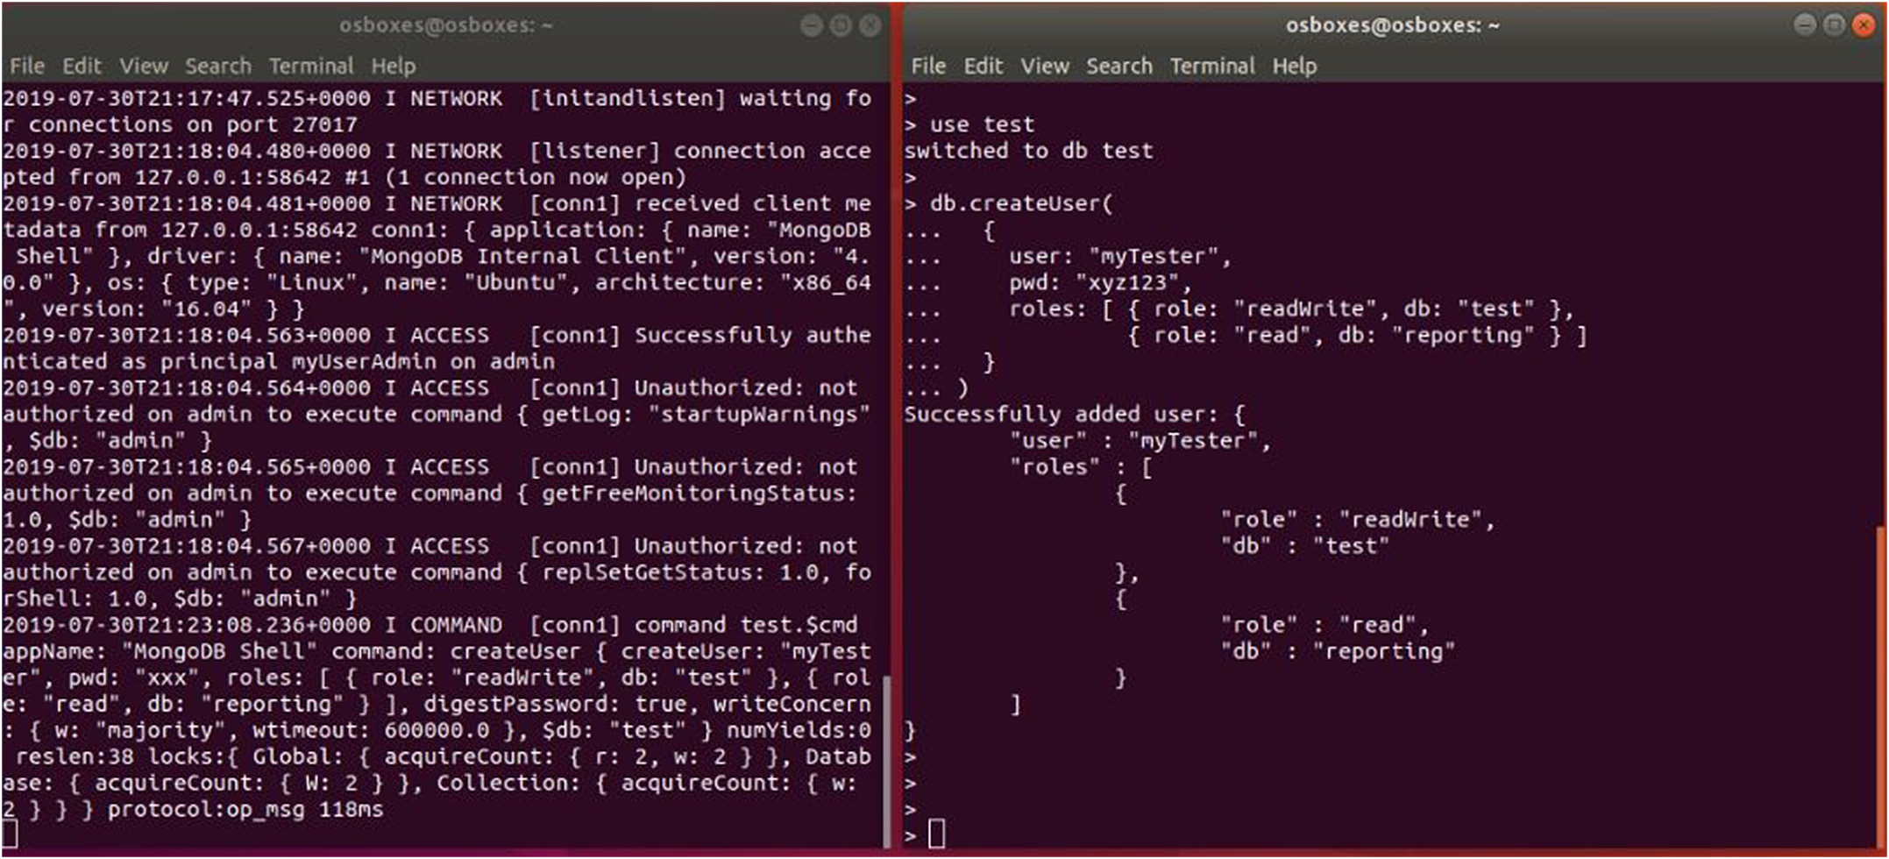

**Fig. 14.** While server is listing at left side, Client at right add the test user.

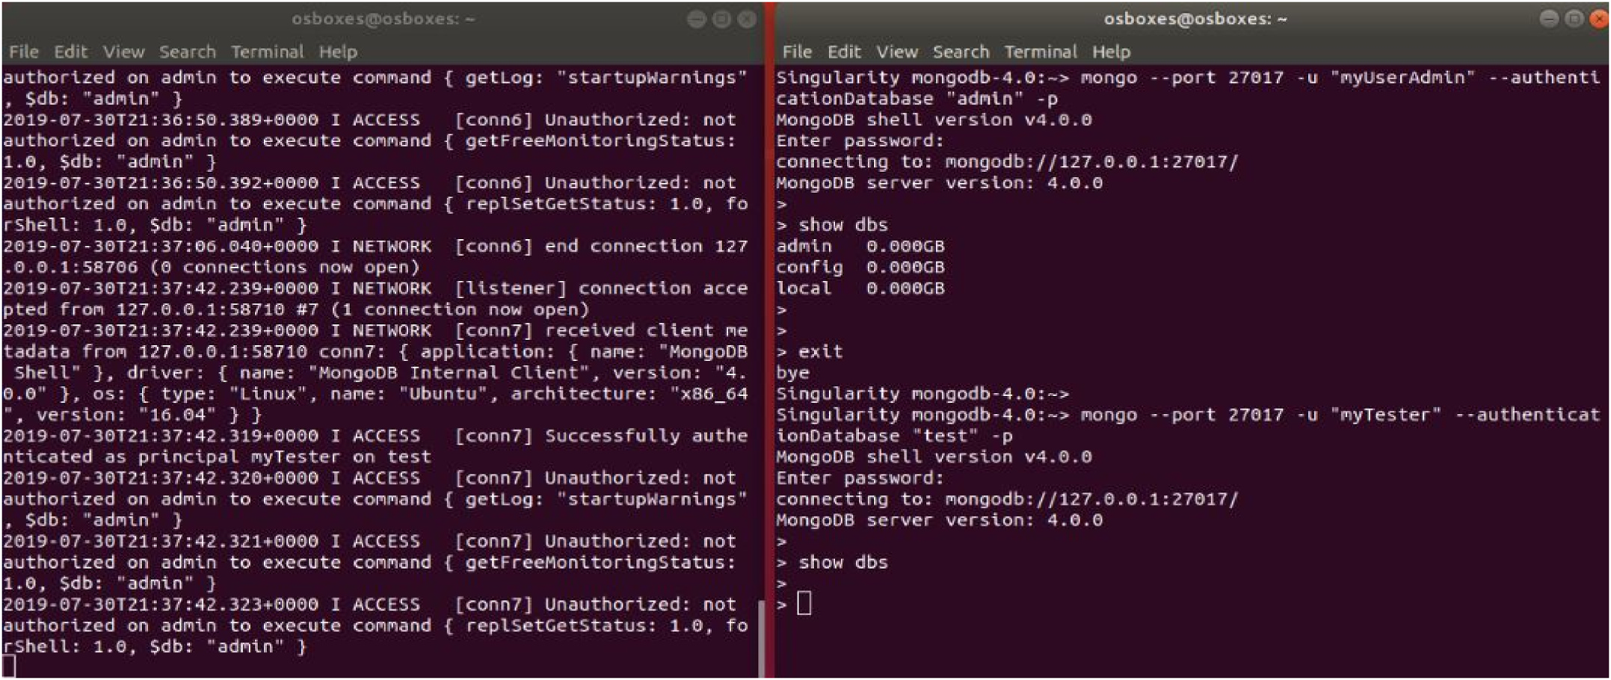

**Fig. 15.** Client at right tests different accessibility levels with two different users.

*3.2. Authorization*

This section shows how to add different privilege levels to different types of users by using access control roles. To add a user, MongoDB provides the db. createUser() method. When adding a user, roles may be assigned roles to the user in order to grant privileges, such as root, admin, and normal user. The first user created in the database should be a user administrator who has privileges to manage other users.

*3.3. Privacy preserving data extractions, transmissions, and loadings*

As discussed previously in section 2.3, privacy preserving data handling is another mechanism to protect the privacy of data in this research, especially with sensitive data. This security mechanism basi-cally converts, an actual data/file header to a numerical data/file header representation. Therefore, it is hard to guess what a particular column’s

10

*A. Mailewa et al.*  *Array 15 (2022) 100236*

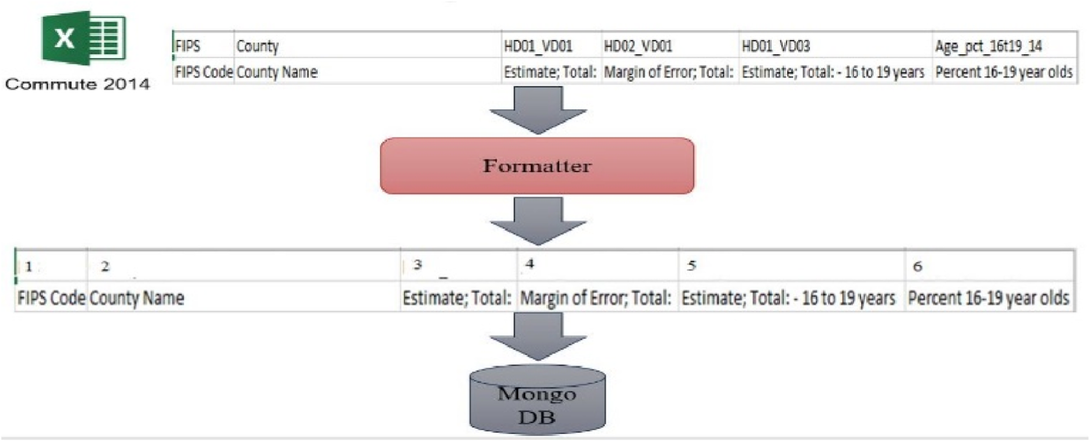

**Fig. 16.** Actual header names maps to numerical values.

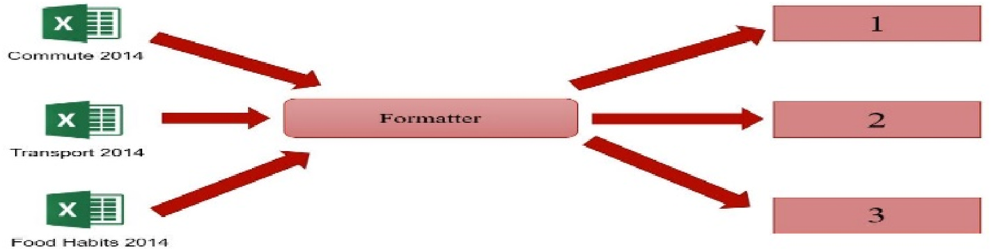

**Fig. 17.** Actual file names maps to numerical values.

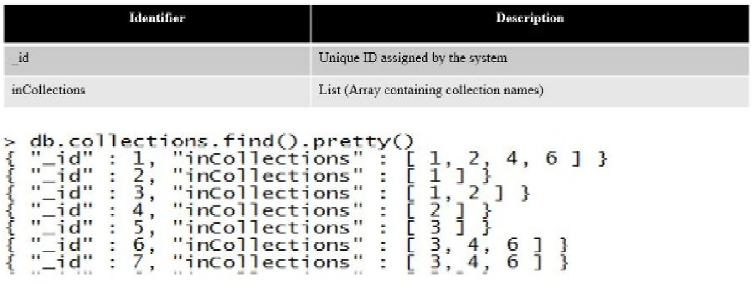

**Fig. 18.** Numerical representation of each header in multiple collections.

project environment by creating “package.json” file as shown in Fig. 6.

Later on we will add more dependencies based on our requirement.

**Step 2**: In order to execute this mechanism, first we need to load Node. js as a singularity container running in the High-Performance Computing Center (HPCC) cluster. Thereafter, we have to load all the required packages into package. json file created in the previous step as shown in Fig. 7.

**Step 3**: In order to store encrypted data in the database, we have created an initial data base model by using “exposome_encryption.js” Java-Script file as shown in Fig. 8. Initially, we have used simple 32 bits base-64 key for the encryption to test the system. But later on, we can use stronger key such as 128-bits or 256-bits in length based on our

11

*A. Mailewa et al.*  *Array 15 (2022) 100236*

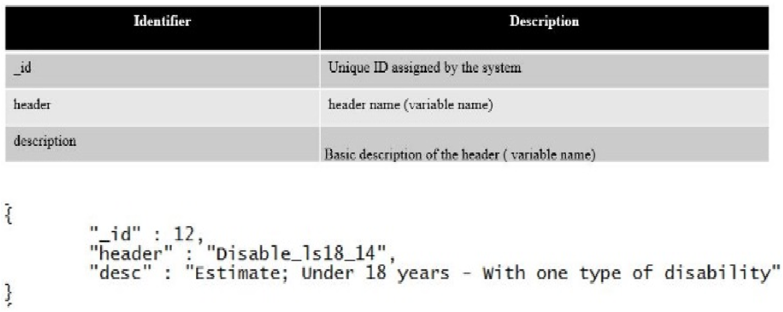

**Fig. 19.** Format of header ID, Actual name, and Description.

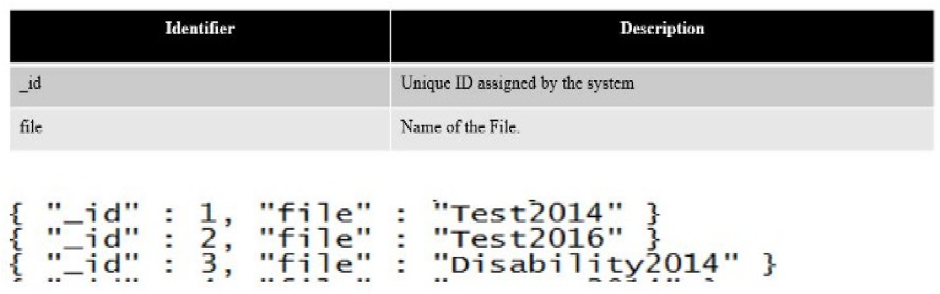

**Fig. 20.** File names that are mapped to the unique headers.

*4.1. Testing the authentication mechanism*

To test this initial version of web based authentication mechanism, first, we create a user “akalanka” and a password “abc 123” via frontend web template’s registration portal as shown below in Fig. 9.

After the user is created, the user’s credentials are stored in the “webAuthentication” database as shown in Fig. 10. Please note that the password is hashed and stored in the “users” collection of the “webAu-thentication” database.

Finally, Fig. 11 shows, in order to access the system, a particular user, applies his/her correct logging credentials through the frontend shown in Fig. 9.

*4.2. Testing the authorization mechanism*

• **Create the user administrator**: After starting two MongoDB in-stances on Singularity containers, set one as server and the other as client. On the client, add the admin user as shown in Fig. 12. After that restart the MongoDB instance with access control and connect again to authenticate as the user administrator as shown in Fig. 13. • **Create additional users as needed**: Once authenticated as the user administrator, again use db. createUser() to create additional users as shown in Fig. 14 where it adds a user “myTester” to the test database who has a “readWrite” role in the “test” database as well as “read” role in the “reporting” database.

The database “test” where the user “myTester” is created is called the user’s authentication database. Although the user would authenticate to this database, the user can have roles in other databases; i.e., the user’s authentication database does not limit the user’s privileges. In Fig. 15, the MongoDB client shows that admin can see and test all the databases available in the server, but the user “myTester” cannot see databases

12

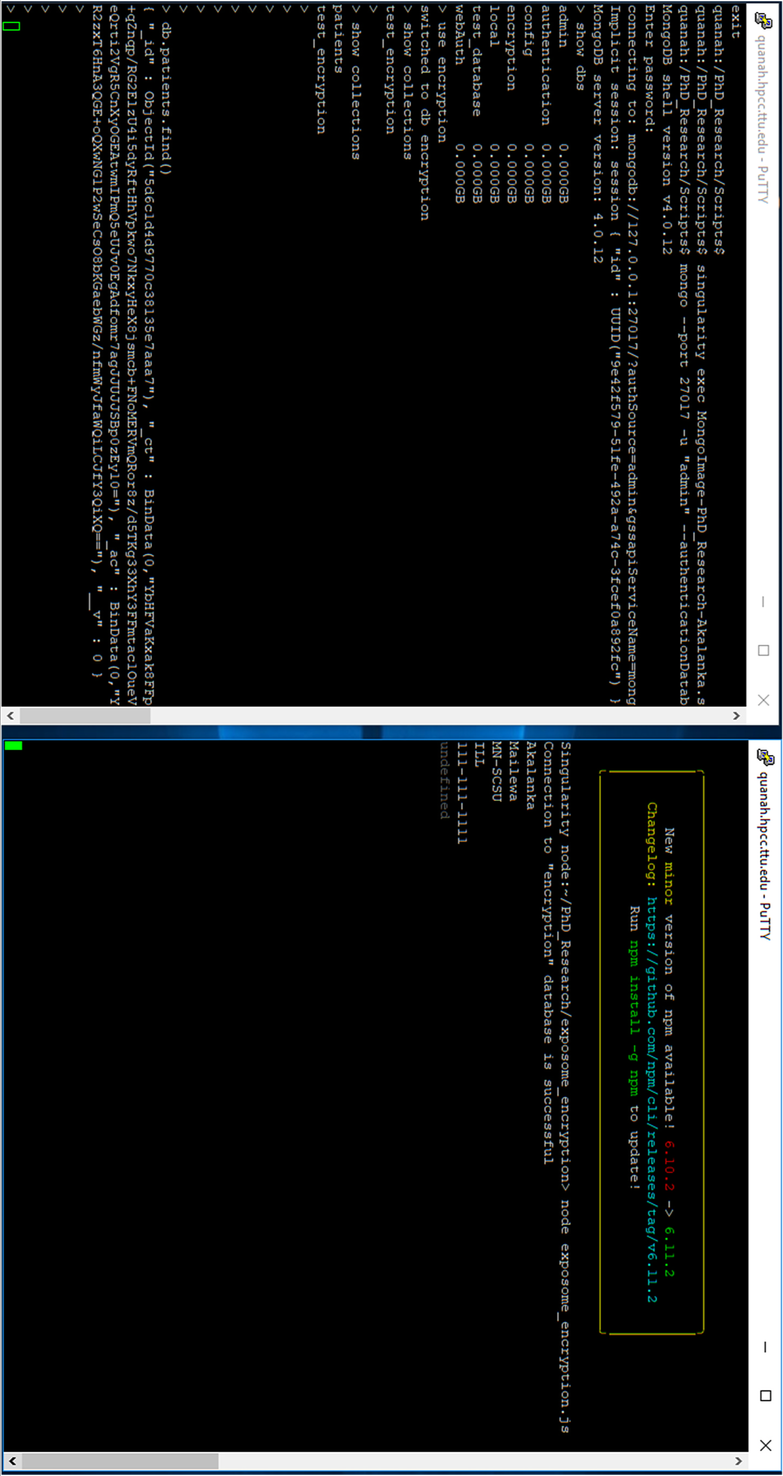

**Fig. 21.** Encrypted data of entire collection at left console and display of the decrypted results on the console at right side.

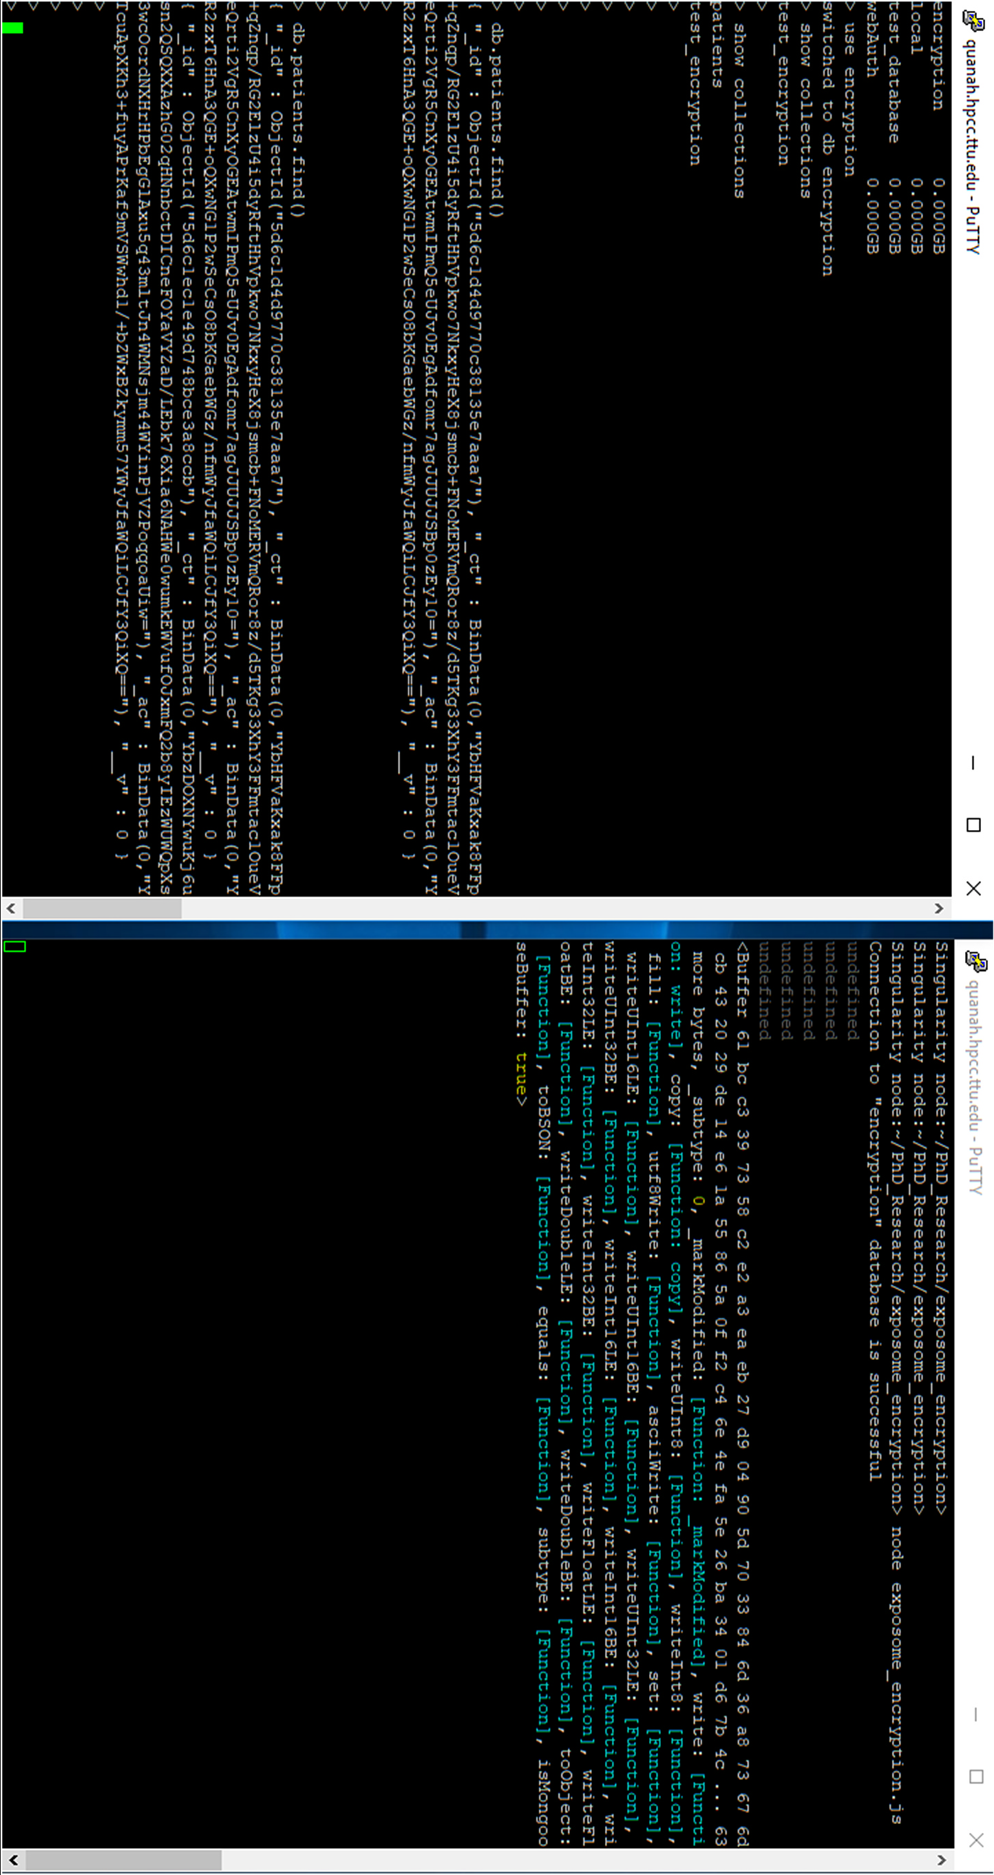

**Fig. 22.** Encrypted data of entire collection at 2nd object of the left console and at right no meaningful data is displayed.

*A. Mailewa et al.*  *Array 15 (2022) 100236*

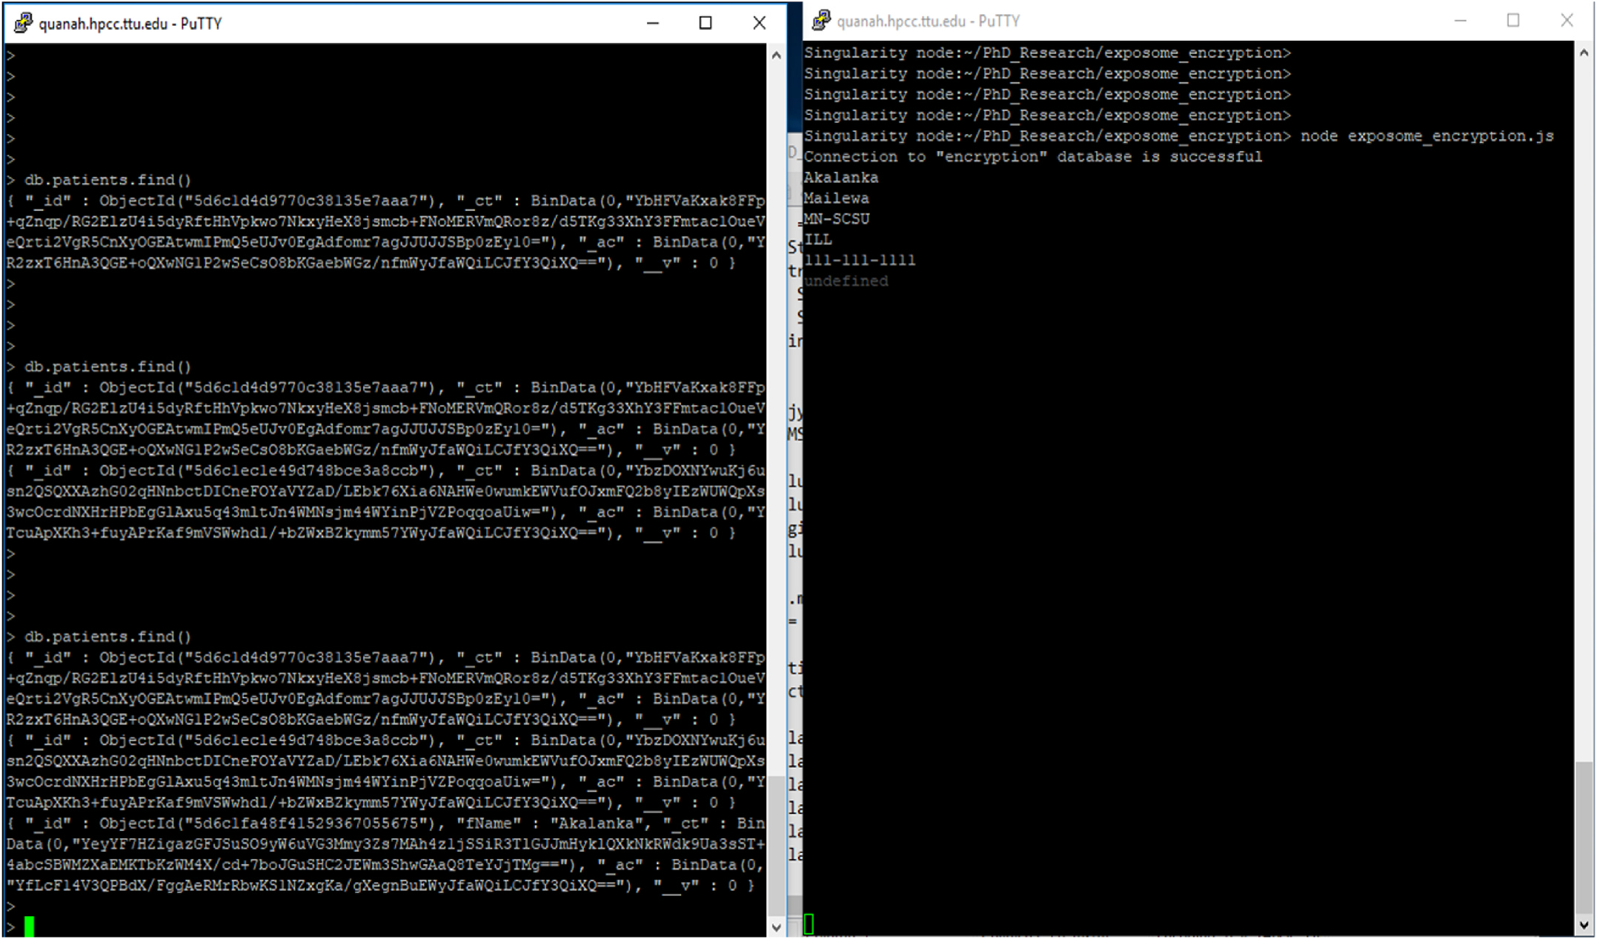

**Fig. 23.** Encrypted data of entire collection except the “fName” field at 3rd object of the left console and display the decrypted results on the console at right side.

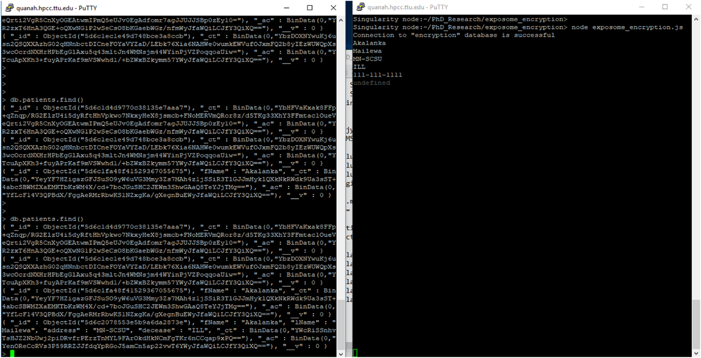

**Fig. 24.** Encrypted data only available in the “SSN” at the left console and display the decrypted results on the console at right side.

js” script with “patientSchema.plugin(encrypt, { encryptionKey: encKey, signingKey: sigKey, decryptPostSave: false}); ” to encrypt the entire collection, but not to decrypt and display on right side console. Left side console’s 2nd object clearly indicates that all the fields of the “patient”

15

*A. Mailewa et al.*  *Array 15 (2022) 100236*

js” script with “patientSchema.plugin(encrypt, { encryptionKey: encKey, signingKey: sigKey, excludeFromEncryption: [’fName’]}); ” to encrypt the entire collection except the “fName” field. Left side console’s 3rd object clearly indicates that all the fields of the “patient” collection’s data is excerpted except the “fName” field. Right side console shows the current connection status to the “encryption” database from the client and decrypted data of the “patient” collection.

Fig. 24 shows the results, after executing the “exposome_encryption. js” script with “patientSchema.plugin(encrypt, { encryptionKey: encKey, signingKey: sigKey, encryptedFields: [’SSN’]}); ” to encrypt only the “SSN” field but not to encrypt all the other fields. Left side console’s 4th object clearly indicates that only the “SSN” field is encrypted and all the other fields’ data is saved in plain text format of the “patient” collection. Right side console shows the current connection status to the “encryp-tion” database from the client and decrypted data of the “patient” collection.

**5. Conclusions**

By using all of the aforementioned security mechanisms, we were able to add additional security to our data analytic framework proposed in the previous three phases of the research as shown through above results were in the first phase we proposed a data analytic framework with MongoDB and LXCs with basic security requirements. Next, in the second phase we proposed a vulnerability analysis testbed to find vul-nerabilities associated with the system. Finally, in the third phase we discussed in detail root causes and some prevention techniques of vul-nerabilities found in the system. Second, the paper clearly presented that it has answered the research question “RQ: How does the data analytic framework with MongoDB and LXCs is designed with enhanced security features?” through our research methodologies by proposing the afore-mentioned security mechanisms and techniques, related to the research question. Third, overall security requirements are dependent on a particular organization’s or person’s security policies and available budget. Therefore, to have a maximum expected security level of this proposed data analytic framework, it is essential to tune the framework in order to meet with the organization’s or person’s security policies in order to add much more security. Finally, it is noteworthy that the overall security of a software system is a shared responsibility of the technical experts as well as its users/clients. Especially, the vulnerabil-ities that may arise through the users play a crucial role, because the security of the system can be compromised if the authenticated users are misguided to exploit the vulnerabilities of the system. Therefore, it is important to bear in mind that the root causes of system vulnerabilities may not always be due to the technical aspects of the security mechanism.

**6. Future works**

It has been proven time and again that there is certainly a positive correlation between the progress of the cybersecurity world and the technological improvements designed to prevent cyber-criminals from exploiting data security loopholes. Each step of this research emphasized the fact that security must be implemented in a multi-layered, evolu-tionary development process, which requires constant investigations to find vulnerabilities in the system using the vulnerability testbed pro-posed in the second phase of the research. It can also be used to test the real data analytic system containing sensitive data. Moreover, adding some other tools such as “OWASP Zed Attack Proxy” and “OpenSCAP” are also compatible with this testbed to verify the detected vulnerabil-ities and to investigate the undetected vulnerabilities, are associated with all four areas: “images with containers,” “host,” “network,” and “MongoDB application.” Thus, adding more tools to the current testbed will enable experts to perform more tests and re-do the experiments to find previously undetected vulnerabilities. Based on these new vulner-abilities, a new data analytic framework will be proposed. This

16

*A. Mailewa et al.*  *Array 15 (2022) 100236*

[16] Vijayakumar Pandi, Chang Victor, Jegatha Deborah L, Bharat S, Kshatriya Rawal.

Key management and key distribution for secure group communication in mobile and cloud network. 2018. p. 123–5. [https://doi.org/10.1016/j.](https://doi.org/10.1016/j.future.2018.03.027)

[future.2018.03.027](https://doi.org/10.1016/j.future.2018.03.027).

[17] [Jena Swagat Kumar, Krishna Tripathy Bata, Gupta Prachi, Das Satyabrata.](http://refhub.elsevier.com/S2590-0056(22)00073-X/sref17)

[A Kerberos based secure communication system in smart (internet of things)](http://refhub.elsevier.com/S2590-0056(22)00073-X/sref17) [environment. J Comput Theor Nanosci 2019;16(5–6):2381–8.](http://refhub.elsevier.com/S2590-0056(22)00073-X/sref17)

[18] [Matotek Dennis, James Turnbull, Peter Lieverdink. Directory services. In: Pro Linux](http://refhub.elsevier.com/S2590-0056(22)00073-X/sref18) [System Administration. Berkeley, CA: Apress; 2017. p. 733–97.](http://refhub.elsevier.com/S2590-0056(22)00073-X/sref18)

[19] [Wen Shuo, Yuan Xue, Xu Jing, Yang Hongji, Li Xiaohong, Song Wenli, Si Guannan.](http://refhub.elsevier.com/S2590-0056(22)00073-X/sref19)

[Toward exploiting access control vulnerabilities within mongodb backend web](http://refhub.elsevier.com/S2590-0056(22)00073-X/sref19) [applications. In: 2016 IEEE 40th Annual Computer Software and Applications](http://refhub.elsevier.com/S2590-0056(22)00073-X/sref19) [Conference (COMPSAC). vol. 1. IEEE; 2016. p. 143–53.](http://refhub.elsevier.com/S2590-0056(22)00073-X/sref19)

[20] [Yerlikaya ¨Ozlem, Dalkılıç G¨okhan. Authentication and authorization mechanism](http://refhub.elsevier.com/S2590-0056(22)00073-X/sref20) [on message queue telemetry transport protocol. In: 2018 3rd International](http://refhub.elsevier.com/S2590-0056(22)00073-X/sref20) [conference on computer science and engineering (UBMK). IEEE; 2018. p. 145–50](http://refhub.elsevier.com/S2590-0056(22)00073-X/sref20).

[21] [Feng Qi, He Debiao, Zeadally Sherali, Liang Kaitai. BPAS: blockchain-assisted](http://refhub.elsevier.com/S2590-0056(22)00073-X/sref20) privacy-preserving authentication system for vehicular ad-hoc networks. IEEE Transactions on Industrial Informatics 2020;16(6):4146–55. [https://doi.org/](https://doi.org/10.1109/TII.2019.2948053) [10.1109/TII.2019.2948053](https://doi.org/10.1109/TII.2019.2948053).

[22] [Abosaif Aghabi N, Haitham](https://doi.org/10.1109/TII.2019.2948053) S Hamza. Quality of service-aware service selection algorithms for the internet of things environment: a review paper. Array 2020;8: 100041. <https://doi.org/10.1016/j.array.2020.100041>.

[23] [Jose Benymol, Abraham Sajimon. Exploring the merits of nosql: a study based on](http://refhub.elsevier.com/S2590-0056(22)00073-X/sref23) [mongodb. In: 2017 International Conference on Networks & Advances in](http://refhub.elsevier.com/S2590-0056(22)00073-X/sref23) [Computational Technologies (NetACT). IEEE; 2017. p. 266–71.](http://refhub.elsevier.com/S2590-0056(22)00073-X/sref23)

[24] [Shih Dong-Her, Huang Feng-Chuan, Lai Wei-Hao, Shih Ming-Hung. Privacy](http://refhub.elsevier.com/S2590-0056(22)00073-X/sref24) [preserving and performance analysis on not only SQL database aggregation in](http://refhub.elsevier.com/S2590-0056(22)00073-X/sref24) [bigdata era. In: 2017 IEEE 2nd International Conference on Cloud Computing and](http://refhub.elsevier.com/S2590-0056(22)00073-X/sref24) [Big Data Analysis (ICCCBDA). IEEE; 2017. p. 56–60.](http://refhub.elsevier.com/S2590-0056(22)00073-X/sref24)

[25] [Tian Xingbang, Huang Baohua, Wu Min. A transpare](http://refhub.elsevier.com/S2590-0056(22)00073-X/sref24)[nt middleware for encrypting](http://refhub.elsevier.com/S2590-0056(22)00073-X/sref25) [data in MongoDB. In: 2014 IEEE Workshop on Electronics, Computer and](http://refhub.elsevier.com/S2590-0056(22)00073-X/sref25) [Applications. IEEE; 2014. p. 906–9.](http://refhub.elsevier.com/S2590-0056(22)00073-X/sref25)

[26] [Simkhada Emerald, Shrestha Elisha, Pandit Sujan, Sherchand Upasana, Mailewa](http://refhub.elsevier.com/S2590-0056(22)00073-X/sref26) [Dissanayaka Akalanka. Security threats/attacks via BOTNETS and botnet detection](http://refhub.elsevier.com/S2590-0056(22)00073-X/sref26) [& prevention techniques in computer networks: a review. In: The Midwest](http://refhub.elsevier.com/S2590-0056(22)00073-X/sref26) [Instruction and Computing Symposium. (MICS). Fargo, ND: North Dakota State](http://refhub.elsevier.com/S2590-0056(22)00073-X/sref26) [University; April .](http://refhub.elsevier.com/S2590-0056(22)00073-X/sref26)

[27] [Humphrey M, Steele J, Kim IK, Kahn MG, Bondy J, Ames M. CloudDRN: a](http://refhub.elsevier.com/S2590-0056(22)00073-X/sref27) [Lightweight, end-to-end system for sharing distributed research data in the cloud.](http://refhub.elsevier.com/S2590-0056(22)00073-X/sref27) [In: eScience (eScience), 2013 IEEE 9th International Conference on; 2013.](http://refhub.elsevier.com/S2590-0056(22)00073-X/sref27)

[p. 254–61.](http://refhub.elsevier.com/S2590-0056(22)00073-X/sref27)

[28] [Angrish Atin, Starly Binil, Lee Yuan-Shin, Cohen Paul H. A flexible data schem](http://refhub.elsevier.com/S2590-0056(22)00073-X/sref28)a [and system architecture for the virtualization of manufacturing machines (VMM).](http://refhub.elsevier.com/S2590-0056(22)00073-X/sref28) [J Manuf Syst 2017;45:236–47.](http://refhub.elsevier.com/S2590-0056(22)00073-X/sref28)

[29] [Makowski Łukasz, Grosso Pao](http://refhub.elsevier.com/S2590-0056(22)00073-X/sref28)la. Evaluation of virtualization and traffic filtering methods for container networks. Future Generat Comput Syst 2019;93:345–57. <https://doi.org/10.1016/j.future.2018.08.012>.

[30] [Mailewa Akalanka, Herath Jayantha. Operati](https://doi.org/10.1016/j.future.2018.08.012)[ng systems learning environment](http://refhub.elsevier.com/S2590-0056(22)00073-X/sref30) [with VMware. In: The Midwest Instruction and Computing Symposium. Verona,](http://refhub.elsevier.com/S2590-0056(22)00073-X/sref30) [WI: MICS); April .](http://refhub.elsevier.com/S2590-0056(22)00073-X/sref30)

[31] [Zhipeng Zhang, Chandel Sonali, Sun Jingyao, Yan Shilin, Yu Yunnan, Zang Jingji.](http://refhub.elsevier.com/S2590-0056(22)00073-X/sref31)

[Vpn: a boon or trap?: a comparative study of mpls, ipsec, and ssl virtual private](http://refhub.elsevier.com/S2590-0056(22)00073-X/sref31) [networks. In: 2018 Second International Conference on Computing Methodologies](http://refhub.elsevier.com/S2590-0056(22)00073-X/sref31) [and Communication (ICCMC). IEEE; 2018. p. 510–5.](http://refhub.elsevier.com/S2590-0056(22)00073-X/sref31)

[32] [Chokhawala Kirit I, Chuabay Vinit Kumar, Patel AR. Secure web application:](http://refhub.elsevier.com/S2590-0056(22)00073-X/sref32) [preventing application injections. 2016.](http://refhub.elsevier.com/S2590-0056(22)00073-X/sref32)

[33] [Bhathal Gurjit Singh, Singh Amardeep.](http://refhub.elsevier.com/S2590-0056(22)00073-X/sref32) Big data: hadoop framework   
vulnerabilities, security issues and attacks. Array 2019;1:100002. [https://doi.org/](https://doi.org/10.1016/j.array.2019.100002) [10.1016/j.array.2019.100002](https://doi.org/10.1016/j.array.2019.100002).

[34] [Saxena Upaang, Sachdeva Shelly. An insightful view on security and performance](http://refhub.elsevier.com/S2590-0056(22)00073-X/sref34) [of NoSQL databases. In: International Conference on Recent Developments in](http://refhub.elsevier.com/S2590-0056(22)00073-X/sref34) [Science, Engineering and Technology. Singapore: Springer; 2017. p. 643–53.](http://refhub.elsevier.com/S2590-0056(22)00073-X/sref34)

[35] [Dayley Brad, Dayley Brendan, Dayley Caleb. Node. js, MongoDB and Angular Web](http://refhub.elsevier.com/S2590-0056(22)00073-X/sref35) [Development: the definitive guide to using the MEAN stack to build web applications. Addison-Wesley Professional; 2017.](http://refhub.elsevier.com/S2590-0056(22)00073-X/sref35)

[36] [Huluka Daniel, Popov Oliver. Root cause analys](http://refhub.elsevier.com/S2590-0056(22)00073-X/sref35)[is of session management and](http://refhub.elsevier.com/S2590-0056(22)00073-X/sref36) [broken authentication vulnerabilities. In: World Congress on Internet Security](http://refhub.elsevier.com/S2590-0056(22)00073-X/sref36) [(WorldCIS-2012). IEEE; 2012. p. 82–6.](http://refhub.elsevier.com/S2590-0056(22)00073-X/sref36)

[37] [Kritikos Kyriakos, Magoutis Kostas, Pa](http://refhub.elsevier.com/S2590-0056(22)00073-X/sref36)poutsakis Manos, Ioannidis Sotiris. A survey on vulnerability assessment tools and databases for cloud-based web applications. Array 2019;3:100011. <https://doi.org/10.1016/j.array.2019.100011>.

[38] [Lin Zhiqiang, Jiang Xuxian, Xu Dongyan, Mao Bing, Xie Li. AutoPaG: towards](http://refhub.elsevier.com/S2590-0056(22)00073-X/sref38) [automated software patch generation with source code root cause identificatio](http://refhub.elsevier.com/S2590-0056(22)00073-X/sref38)n [and repair. In: Proceedings of the 2nd ACM symposium on Information, computer](http://refhub.elsevier.com/S2590-0056(22)00073-X/sref38) [and communications security. ACM; 2007. p. 329–40.](http://refhub.elsevier.com/S2590-0056(22)00073-X/sref38)

[39] [Fernandez Eduardo B. A methodology for secure software design. Software](http://refhub.elsevier.com/S2590-0056(22)00073-X/sref39) [Engineering Researchand Practice; 2004.](http://refhub.elsevier.com/S2590-0056(22)00073-X/sref39)

[40] [Youssef Ahmed E. A framework for secure healthcare systems based on big data](http://refhub.elsevier.com/S2590-0056(22)00073-X/sref40) [analytics in mobile cloud computing environments. Int J Ambient Syst Appl 2014;2](http://refhub.elsevier.com/S2590-0056(22)00073-X/sref40) [(no. 2):1–11.](http://refhub.elsevier.com/S2590-0056(22)00073-X/sref40)

[41] [Chakravorty Antorweep, Wlodarczyk Tomasz, Rong Chunming. Privacy preserving](http://refhub.elsevier.com/S2590-0056(22)00073-X/sref41) [data analytics for smart homes. In: 2013 IEEE Security and Privacy Workshops.](http://refhub.elsevier.com/S2590-0056(22)00073-X/sref41) [IEEE; 2013. p. 23–7.](http://refhub.elsevier.com/S2590-0056(22)00073-X/sref41)

[42] [Abraham Subil, Nair](http://refhub.elsevier.com/S2590-0056(22)00073-X/sref41) [Suku. Cyber security analytics: a stochastic model for security](http://refhub.elsevier.com/S2590-0056(22)00073-X/sref42) [quantification using absorbing Markov chains. J Commun 2014;9(12):89](http://refhub.elsevier.com/S2590-0056(22)00073-X/sref42)9[–907.](http://refhub.elsevier.com/S2590-0056(22)00073-X/sref42)

17

*A. Mailewa et al.*  *Array 15 (2022) 100236*

Dr. Lisa Gittner is an Associate Professor in the Department of

Reserve University as a Program Director for a National Insti-tute of Health/ National Institute of Minority Health and Health Disparities grant (1RC2-MD004760-01) studying mechanisms to activate medically and socially disenfranchised patients to advocate for their own health. She is an Associate Member of the Laura W. Bush Institute for Women’s Health and a Member of The American Society of Public Administrators. Public Health at Texas Tech University Health Sciences Center. She has a Bachelor and Master of Science in Biochemistry/ Toxicology from Wright State University and received her Doctorate in Public Administration and Health Policy from University of Akron. Dr. Gittner’s post-doc was at Case Western

Dr. Gittner is an expert on peer social support to improve health outcomes. Her research focuses on the management of life course disease through social networks. Dr. Gittner’s prior research has been funded by the Robert Wood Johnson Foundation, Garfield Foun-dation, Eastbay Foundation and Komen Foundation. Previously, Dr. Gittner was Director of Research for Kaiser Permanente and Director of novel dose development for Watson Pharmaceutical Company, Inc.

18